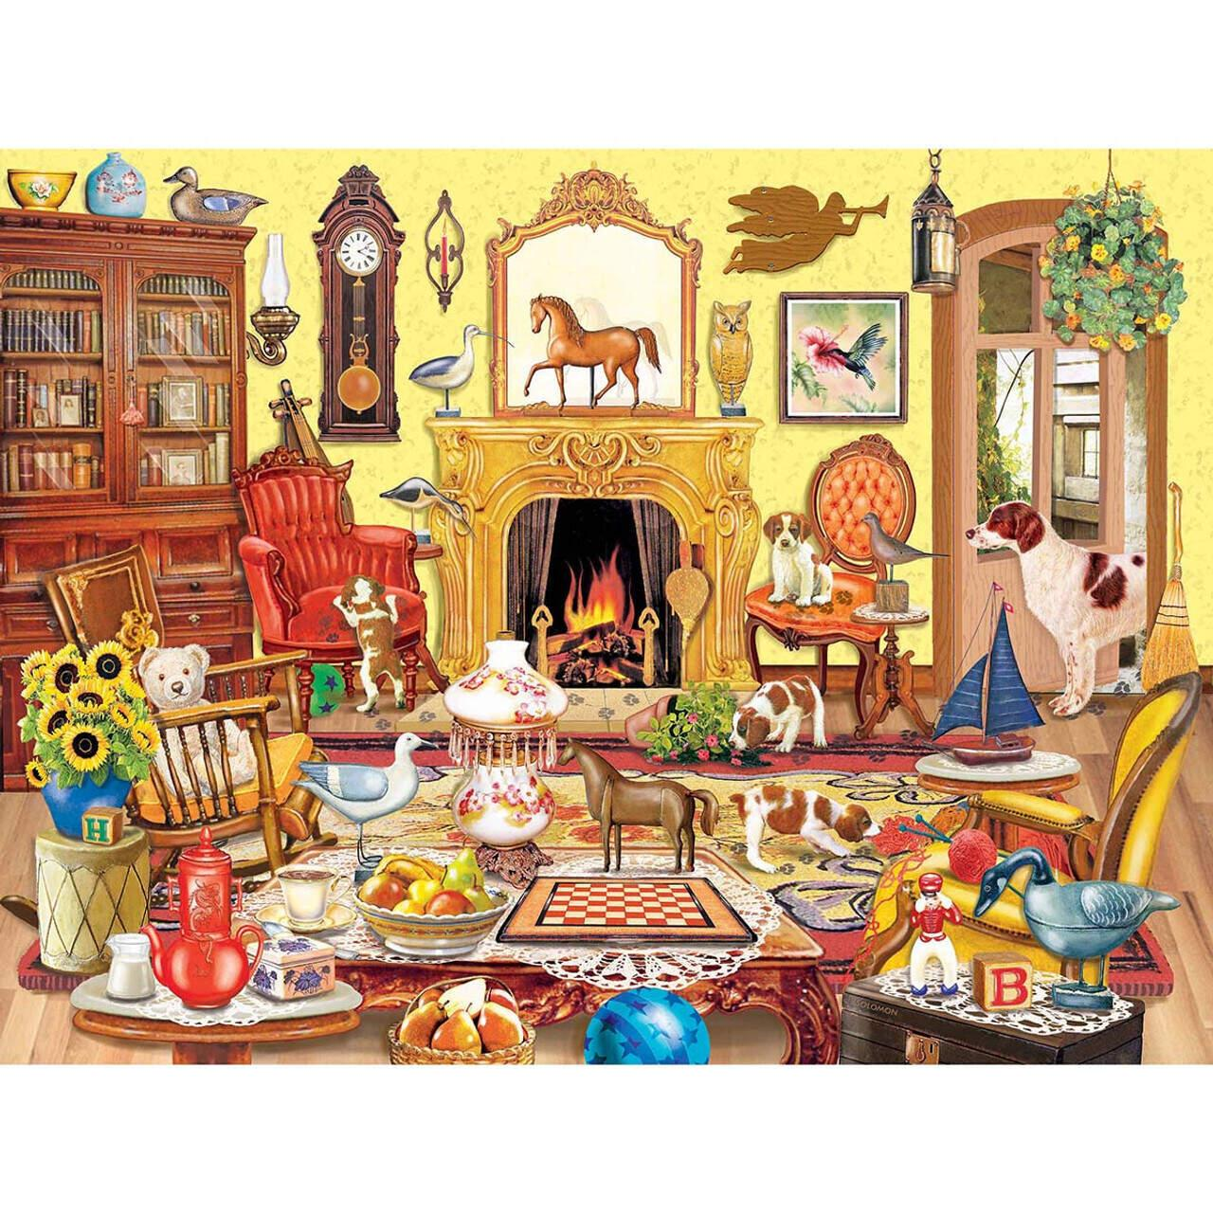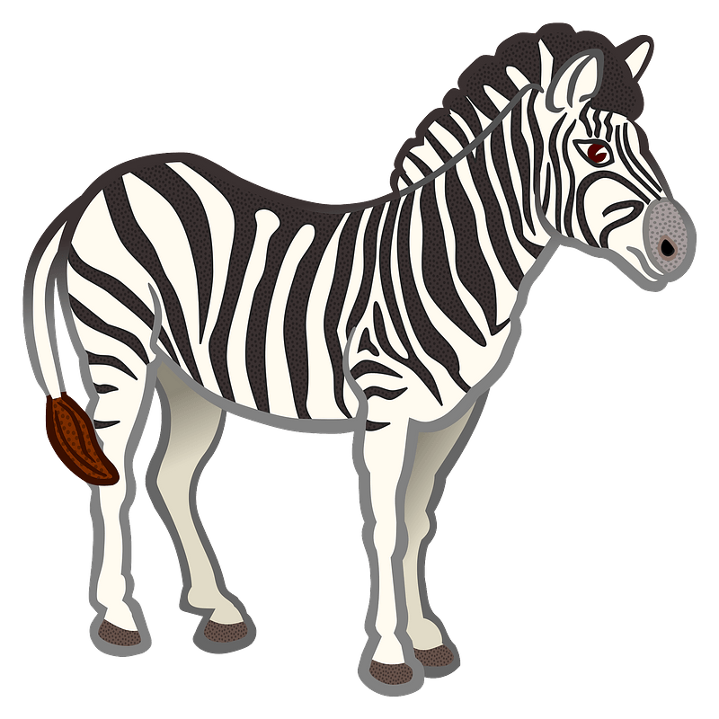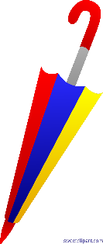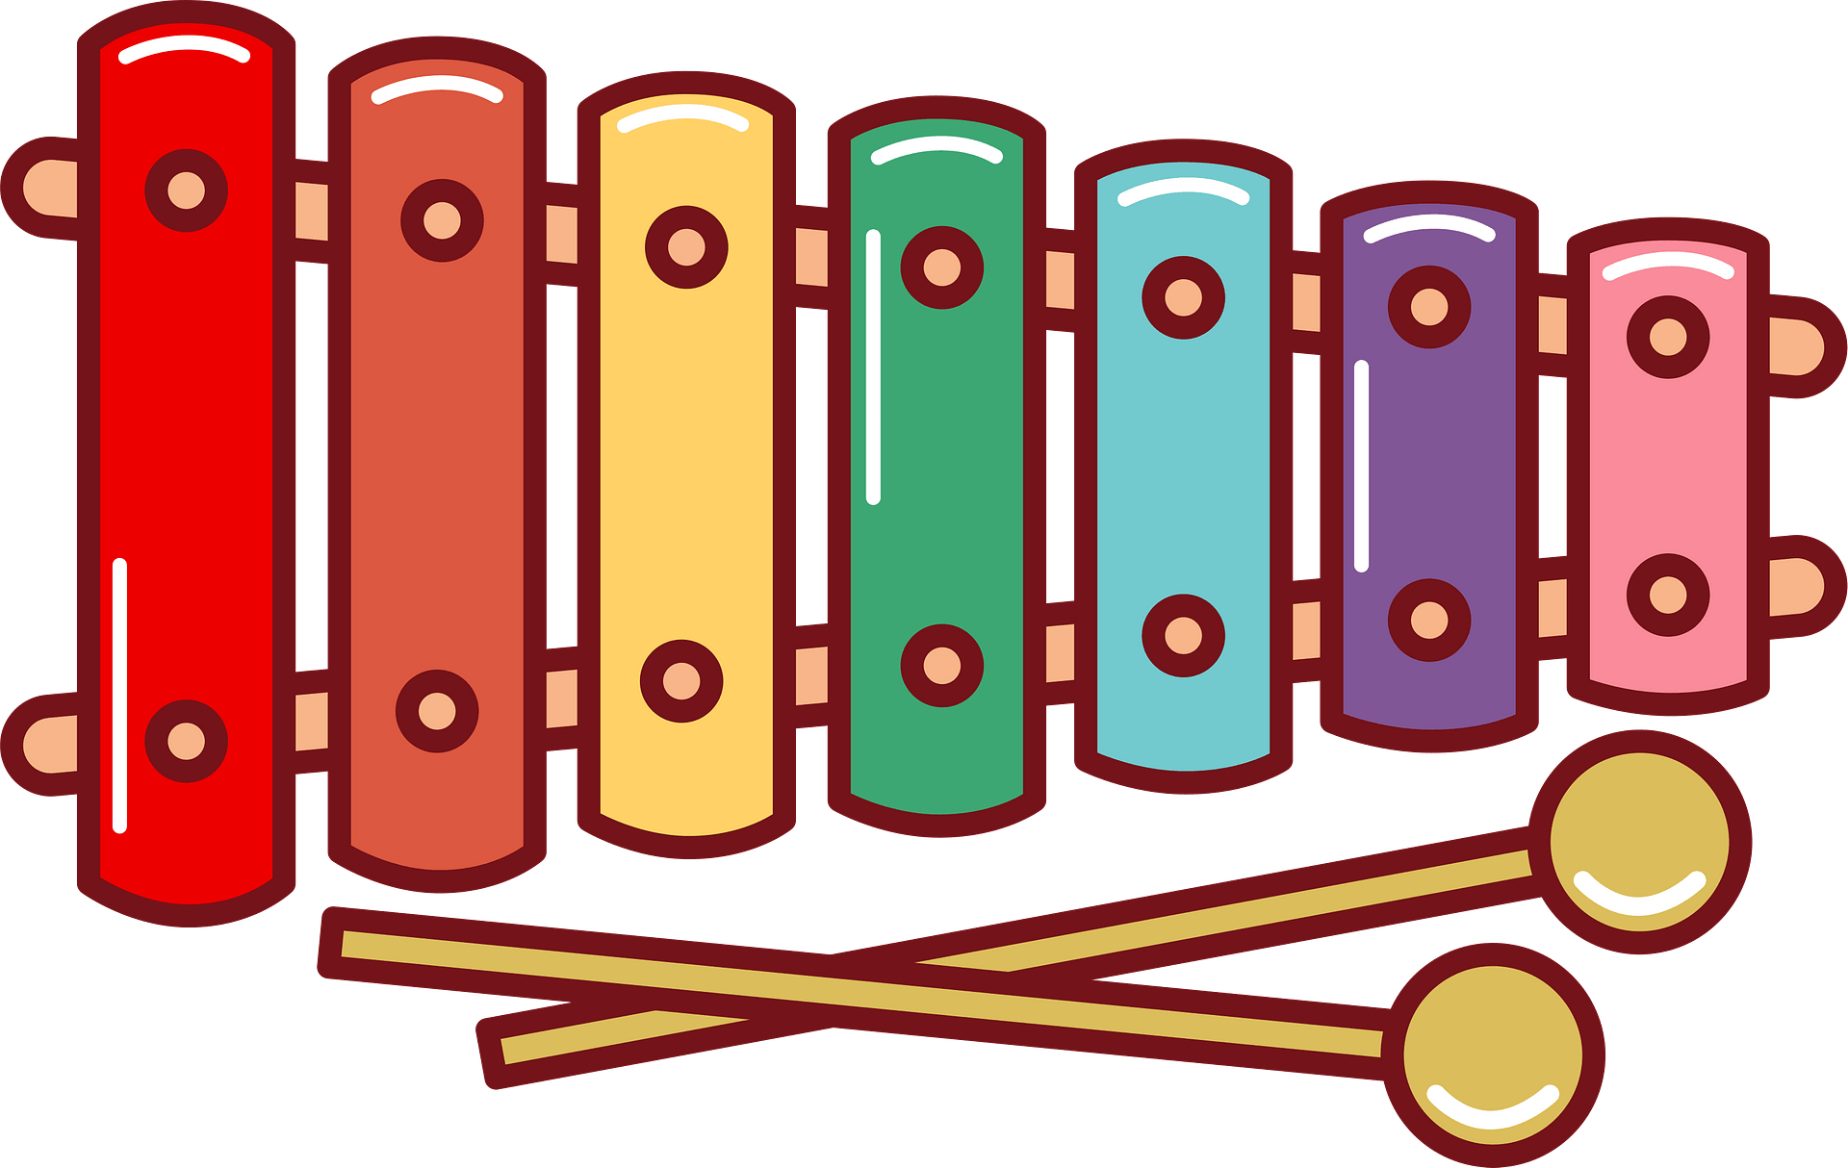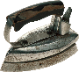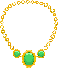

Alphabet Challenge

**Apple**

**Bird**

**Chair**

**Dog**

**Eggs**

**Fire**

**Game**

**Horse**

**Instrument**

**Jug**

**kitchen kettler**

**Library**

**Milk**

**Necklace**

**Owl**

**Pear**

**Quill**

**Rug**

**Ship**

**Toy**

**Umbrella**

**Vase**

**Window**

**Xylophone**

**Yellow**

**Zebra**



A. Apple: The apple is a round, red fruit.

B. Bird: The bird sang melodiously in the tree.

C. Chair: I sat on the comfortable chair and rested.

D. Dog: The dog happily played in the park.

E. Eggs: I bought a dozen fresh eggs at the market.

F. Fire: The fire crackled and warmed the room.

G. Game: We had a lot of fun playing the board game.

H. Horse: I rode a horse and galloped through the field.

I. Instrument: The musician skillfully played the instrument.

J. Jug: I poured fresh juice into the glass jug.

K. Kitchen Kettle: I boiled water in the kitchen kettle.

L. Library: I spent hours in the library reading interesting books.

M. Milk: I drank a glass of cold milk to refresh myself.

N. Necklace: She wore a beautiful necklace with a diamond pendant.

O. Owl: The owl hooted loudly in the middle of the night.

P. Pear: The pear was sweet and juicy, perfect for a snack.

Q. Quill: The writer dipped the quill pen in ink and began to write.

R. Rug: The soft rug felt cozy under my feet.

S. Ship: The ship sailed across the ocean with a full crew.

T. Toy: The child played happily with the toy car.

U. Umbrella: I opened my umbrella to shield myself from the rain.

V. Vase: The vase was filled with colorful flowers.

W. Window: I looked out the window and saw the beautiful sunset.

X. Xylophone: The musician played a beautiful melody on the xylophone.

Y. Yellow: The bright yellow sunflower stood out in the garden.

Z. Zebra: The zebra had black and white stripes and grazed peacefully in the savannah.